Belejar Tenses

Hari Pertama

Pertemuan 1

Belajar Dasar Kalimat

SPO

Bahasa Indonesia ataupun inggris, bentuk dasar kalimatnya sama….

Yang berbeda adalah tentang ‘kata kerja’. Bahasa inggris harus menggunakan kata kerja

Latihan Pertama

1. I work at a bank
2. I am a manajer
3. He/she works at a hotel
4. They come form Australia
5. They are form Australia
6. He is like me
7. I like chiken
8. He likes chiken

Kata kerja harus di tambahkan + s/es = kata kerja + s/es

Kalimat dasar

Subjek+kata kerja (s/es)

Subjek + am/is/are + bukan kata kerja

# mengembangkan kalimat dasar

Latihan dua

1. I have sent your money
2. I have been waiting for tow hour
3. They have been playing since morning
4. He has arrived

I = Whare rita and diana?

U = they have gone to campus

I = buy theway yesterday I come here but not see you

U = ohhh…. I had gone to kamus

Pertemuan 2

Kata kerja memiliki 3 bentuk yaitu

Contoh = Study, - Studied, - studied

Kata bantu juga memilikiu 3 bentuk

Am/is/are, - was/were, - been

Kata bantu (sudah)

Have/has –had

KATA BENTUK KERJA ke DUA

Kata kerja l -> nyata sekarang

Kata kerja ll -> nyata lalu

Kalimat dasar

Sekarang Lalu

Am/is was

Are were

Kalimat sedang

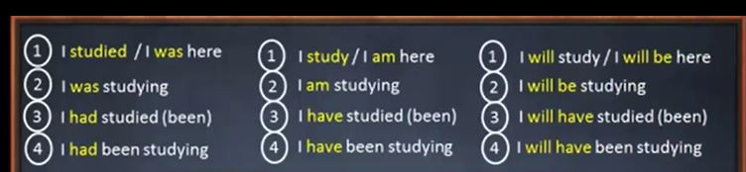

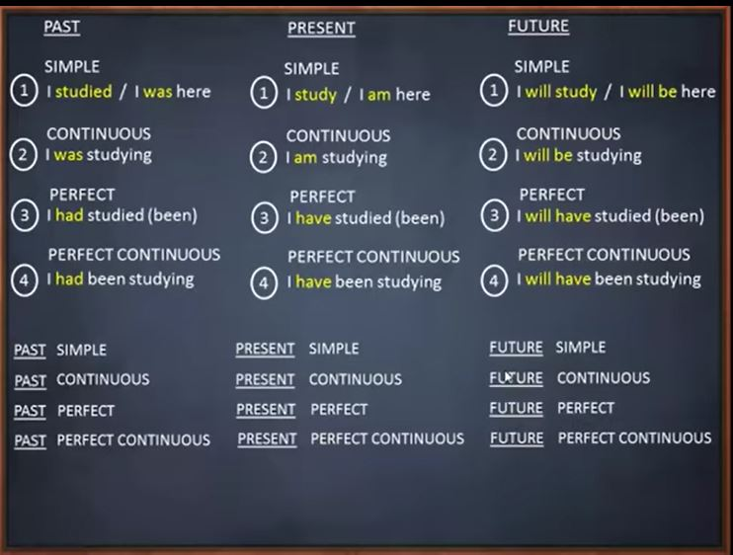

Latihan kalimat dasar :

1. I watch tv every night
2. I am hungry
3. He is smart
4. He watches tv every night
5. She is beautiful
6. She plays piano
7. They play the guitar
8. They are talented

Latihan kalimat sedang :

1. I am a employee

* I work form Monday to Friday
* I am working

1. They are athletes

* They practice twice a week
* They are practicing

1. She is a teacher

* She teaches English
* She is teaching

Latihan kalimat sudah ;

1. He is sick

* He has been sick for three days.
* He takes Aspirin once a day
* He has eaten
* He is sleeping

1. I am in Bali

* I have been in Bali for a week
* I visit Bali twice a year
* I have visited Tanah Lot and Ubud
* I am visiting kutai now

Latihan kalimat sudah sedang

1. I am in the library now
2. I have been in the library since two hours ago
3. I read in the library every weekend
4. I am reading a book about health
5. I have been reading three books so far
6. I have read books about education and politics

Latihan

1. He is a businessman
2. He sells many products
3. He has sold five products today
4. He is explaining a product
5. He has been doing this for two hours
6. He has been in this business for two years

Latihan

1. They are lazy, they watch tv every day
2. He is diligent, he studies evry day
3. He is waiting, he has been waiting since morning
4. He is tired, he is sleeping
5. I have finished, I am sleepy
6. He has been playing since morning
7. I am busy, I am working
8. He is hungry and he has gone
9. I am at home and I am alone
10. We have been fasting for a week

**Kata ganti – pronoun ( Subjek dan objek )**

I know you

You know me

We know them

They know us

He knows her

She knows him

We need them and they need us

I like her and she likes me

He is looking at you

We are here for him

she has been looking for you for an hour

i have texted her many times

You have disappointed us

We are talking with them

He has called me, he is in bandung, he has been in bandung since yesterday

They are here and they are studying with us

Tia and ita are absent toady, they are sick

Iwan is abent today, he is sick, he is sleeping

Ria has graduated, she works at a bank

Nia and roi are in Jakarta and raisa is in bandung

Yuri is studying, ana and nia are watching tv

Dani is sick, he has been sick for three day

Ria is watching, she ha been watching since morning

Yuli has bought a necklace, it is good

A bird is singing, it sings evry morning, I like it

Hari ke 4

Benda majemuk

(kata benda yang di ikuti kata ‘itu’)

Kalaimatnya dibalik

He is in bali

He has been in bali since a week ago

We studys every Monday and thrusday

We are studying 4 main sentences

We have been studying 4 main sentences for five minutes

We have studied tenses

1. Those flowers are very beautiful
2. This book is very good, I like it
3. I have sent this massage to him/her
4. Andi has received that latter
5. Nia and i are cleaning this room
6. Iwan is repairing that old car
7. That old man is still strong
8. That man has been working in this mining company for two years
9. That person is very friendly, he lives in that big house
10. Those people are very friendly, I meet them in this garden everyday
11. That red flower is so beautiful, I like it because it smells good
12. Those flowers are very so beautiful, I like them because they smell good

Hari kelima

( Kata ganti berupa kepunyaan )

Latihan

1. Anwar has read your massage
2. Our friend has been waiting for us
3. My new handphone is broken
4. That is mira’s laptop
5. Those are his belonging
6. This is my friend’s car
7. I have deleted our old pictures
8. Risky likes his new hair
9. His parents are talking with them
10. My father’s friend has bought that big house

1. Rio’s sister is beautiful, I like her eyes
2. My unckel si so handsome, rita likes his smile
3. That big elephant uses its long trunk to grab food
4. Those small elephants use their long trunk for grab food
5. This is mine, yours is over there
6. Rina has taken hers, this is yours
7. My picture isbetter than yours picture
8. Mine is better than yours
9. This is ours and that is theirs
10. They are compering mine with his
11. This is iwan’s money and that is dian’s
12. This laptop is mine and that laptop is yours
13. These books are mine and those books are yours
14. That black pen is yours, mine is out of ink

Hari ke 6

Materi A/AN & THE

I have found the money

They are talking with her/him

I have read the book and I like it

Ria is repairing her speech

We have been waiting for him two hour

That snake has swallowed its pray alive

Armad has called his mother and talk with her

I like rio’s car, especially its color

Rio and friend are watching the movie, the movie is about a advanture

Oohh…the movie is very insparing, I have watched the movie

**Hari ke 7**

**Membuat kalimat negative**

He doesn’t understand but he is not stupid

I am not like them, I am not arrogant

They are not afraid and they don’t care

I don’t know him and he doesn’t live here

She is not alone and she doesn’t need them

I know tem although they are not my friends

I have told her that I am not andi’s brother

Dani is not a soldier but a policeman

That is not my money, that is iwan’s money

I an not yours and you are not mine

Mereka tidak tertarik

Meraka bukan guru

I bukan seorang pemain bola

Saya tidak tuli

Dia tidak sendirian

Dia bukan pemilik

I am not close with ria, i don’t know much about her, cause I am not her friend

He is not a musician, he doesn’t understand music, so he is not interested in your music

Agus and rais are not here and they don’t work here cause they are not our employe

Hari ke delapan

He is not using your laptop, he is using mine

They are not studying, they are watching tv

I am not talking about you

They are not practicing now cause they are not practice every night

I am not teaching, I don’t teach on Thursday and Saturday

He dosen’t study on Sunday so he is not teaching now, he is sleeping

We have been here since morning but they **have not/haven’t** arrived

I have explained everiting but he **has not/hasn’t** understood

He has been to bali, I **have not/haven’t** been to bali

I have told mita but I **have not/haven’t** told dian

Andi and iwan have finished but rita **has not/hasn’t** finished

Hari ke Sembilan

Go home

Close the door

Be brave

Be polite

Be a man

Be yourself

Don’t be sad and don’t cry

Be honest, don’t lie to me

Don’t worry, Be Happy

Be patient, don’t be angry

Come on time tomorrow, don’t be late

I am not him cause I am not crazy

he doesn’t know, he haven’t seen that new a movie

Let hm alone, don’t disturb him

I haven’t been ever meet him

I haven’t seen her since morning

Don’t use that laptop, that is not yours

Try bee again, don’t be despair

Call him now, don’t be afraid

I don’t know much about him

They are not doing homework them

